**Knee Ligaments**

Knee ligaments are bands of tissue that connect your thigh bone to your lower leg bones. They can be classified into two main groups: collateral ligaments and cruciate ligaments. Sprained and torn knee ligaments are common, especially among athletes. They may be mild, requiring rest and simple treatment, to severe, requiring surgery.

**Overview**

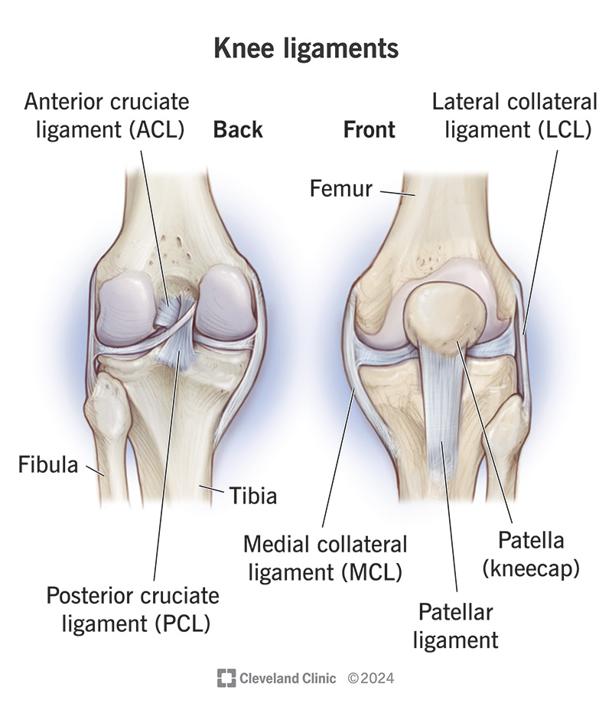Your knee ligaments hold your bones together and help stabilize your knee joint.

**What are knee ligaments?**

Your knee ligaments are rigid, supportive bands of soft tissue that connect your thigh bone ([femur](https://my.clevelandclinic.org/health/body/22503-femur)) in your upper leg to your lower leg bones ([tibia](https://my.clevelandclinic.org/health/body/23026-tibia) and [fibula](https://my.clevelandclinic.org/health/body/23122-fibula-calf-bone)). The ligaments of the knee hold your bones together and help stabilize your [knee joint](https://my.clevelandclinic.org/health/body/24777-knee-joint). They stabilize knee motion and brace your knees for unusual movement.

Although your knee ligaments are strong enough to hold your knee in place, they’re vulnerable to damage and injury. If you injure yourself or develop any pain in your knee ligaments, talk to your healthcare provider right away. Prompt treatment will get you moving again.

**How many ligaments are in the knee?**

There are four main [ligaments](https://my.clevelandclinic.org/health/body/21604-ligament) in your knee. The two collateral ligaments are like straps on each side of your knee. They prevent your knee from moving side to side too much. The two cruciate ligaments are in the center of your knee. They keep your knee from shifting too far forward or backward. The ligaments of the knee are:

* **Medial collateral ligament (MCL).** Your MCL connects your thigh bone (femur) to your shin bone (tibia). Wide and flat, it gives stability to your inner knee.
* **Lateral collateral ligament (LCL).** Your LCL connects your femur to your smaller lower leg bone (fibula). Thinner and rounder than your MCL, it gives stability to your outside (lateral) knee.
* **Anterior cruciate ligament (ACL).**Your ACL connects your femur to your tibia, toward the front. It’s the most commonly injured knee ligament.
* **Posterior cruciate ligament (PCL).** Your PCL also connects your femur to your tibia, toward the back. It’s thicker and stronger than your ACL, so it’s less commonly subject to injury.

**Function**

**What is the purpose of the knee ligaments?**

Knee ligaments have several important jobs. They play a vital role in the functioning of your knee. Knee ligaments:

* Stabilize your knee when your foot strikes a surface
* Connect your thigh bone to your lower leg bones
* Keep your bones in the proper position
* Prevent your knee from twisting or collapsing
* Stabilize your knee joint
* Stop your knee from moving in any unsafe or unnatural directions

**Anatomy**

**Where are the knee ligaments located?**

Your collateral ligaments are located on the sides of your knee. Your medial collateral ligament (MCL) is on the inner side and your lateral collateral ligament (LCL) is on the outer side.

Your anterior cruciate ligament (ACL) and posterior cruciate ligament (PCL) are located inside your knee joint toward the front of your knee. Your PCL crosses behind your ACL, forming an “X.”

**What are knee ligaments made of?**

Knee ligaments are made of strong connective tissue. They contain [collagen](https://my.clevelandclinic.org/health/articles/23089-collagen) — a protein that binds tissue in animals — and elastic fibers that are slightly stretchy.

**Conditions and Disorders**

**Can I injure a knee ligament?**

An injury to a knee ligament is called a sprain (overstretched) or complete rupture (tear). Many [knee sprains](https://my.clevelandclinic.org/health/diseases/knee-sprain) are mild, but torn knee ligaments can be severe. Knee ligament tears include:

* [ACL tear](https://my.clevelandclinic.org/health/diseases/16576-acl-tear)
* [LCL tear](https://my.clevelandclinic.org/health/diseases/21710-lcl-tears)
* [MCL tear](https://my.clevelandclinic.org/health/diseases/21979-mcl-tear)
* [PCL tear](https://my.clevelandclinic.org/health/diseases/21793-pcl-posterior-cruciate-ligament-tears)

Knee ligament injuries are common, especially in athletes. You can overstretch or tear a knee ligament when:

* Force is applied to the back of your knee when the joint is partly flexed
* Force is applied to the front of a bent knee (sometimes called “dashboard injury” because it’s common in car accidents)
* Force is applied to the side of your knee when your foot is on the ground (for example, during a tackle)
* Your knee is hyperextended (straightens too much), usually by force
* Your knee joint twists in an unnatural way (for example, when playing basketball or skiing)

**How can a healthcare provider tell if I’ve injured a knee ligament?**

If you seek medical attention for a knee injury, a healthcare provider may:

* Ask you about your symptoms and when they started
* Perform a [physical exam](https://my.clevelandclinic.org/health/diagnostics/17366-physical-examination) by looking at your injured knee, assessing how it moves and comparing it to your other knee
* Take [X-rays](https://my.clevelandclinic.org/health/diagnostics/21818-x-ray) to rule out a broken leg bone, [kneecap (patella)](https://my.clevelandclinic.org/health/body/25038-patella) or other problem
* Order an [MRI](https://my.clevelandclinic.org/health/diagnostics/4876-magnetic-resonance-imaging-mri) to take pictures of your knee ligaments

**What are the common treatments for knee injuries?**

Treatment for a knee sprain or torn ligament can vary greatly, depending on:

* How long you’ve had symptoms
* How many knee ligaments are injured
* The severity of the injury
* Whether pain or inability to put weight on your knee is interfering with your life
* Whether the injury weakens your knee and puts you at risk for more injuries in the future

Treatment may range from nonsurgical to surgical:

* The [RICE method](https://my.clevelandclinic.org/health/treatments/rice-method), which stands for rest, ice, compression and elevation
* [Nonsteroidal anti-inflammatory drugs (NSAIDs)](https://my.clevelandclinic.org/health/treatments/11086-non-steroidal-anti-inflammatory-medicines-nsaids)
* Assistive devices (for example, [crutches](https://my.clevelandclinic.org/health/treatments/15543-how-to-use-crutches) to help you keep weight off your knee)
* Immobilization (like a [knee brace](https://my.clevelandclinic.org/health/treatments/21034-knee-brace))
* [Physical therapy](https://my.clevelandclinic.org/health/treatments/physical-therapy)
* Surgery by an [orthopedic surgeon](https://my.clevelandclinic.org/health/articles/orthopedic-surgeon-orthopedist) to repair or rebuild your damaged ligament(s)

**Care**

**How can I prevent knee ligament injuries?**

You can’t prevent all knee injuries, but you can take steps to keep your knee ligaments safer, especially during physical activity. Steps you can take include:

* Understanding certain sports have higher risks of injury, like basketball, volleyball, soccer and football
* Performing physical activity on level surfaces to decrease the chances you’ll twist your knees
* Maintaining a healthy weight for you to reduce pressure on your knees
* Varying your physical activity routine, combining weight training and aerobic activities (cardio)
* Warming up before you perform any physical activities
* Increasing physical activity intensity gradually and stretching afterward
* Wearing shoes that fit well
* Wearing all appropriate safety equipment for any sports you play

**A note from Cleveland Clinic**

Your knee ligaments are an important part of your knee anatomy. They help keep your knee in place and stabilize the joint. But they’re made of connective tissue that’s easily susceptible to sprains and tears. Talk to a healthcare provider if you have a severe knee injury or repeat injuries. Proper diagnosis and treatment can help prevent pain and future injuries.

